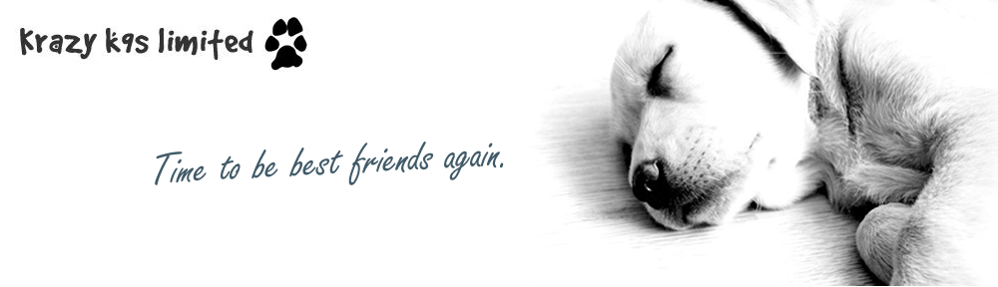 Course Booking Form

Mr/Mrs/Miss ……….…….………… Surname: …………………………………………...…………………………………………….

First Name: ……………………….…………………………………….……………………………….……………………….……………….

Address: ………………………….………………………………………………….……………………………………………………………..

………………………………….………………………………………………………….. Post Code …………………..…………………..

Tel: ……………….……………………. e-mail address: …………………...……………………….…….……………………………
(if you provide an e-mail address your course confirmation and information will be sent to this address)

Dogs Name: …………..……………………………………………..……… Dogs Age: …………….……………………………………

Dogs Breed: ……………………………………..……….………………………………………………………………………………………

Course Date: ………………………………………… Preferred Time: …….… day / evening ………………….………
Actual times will be confirmed when we confirm your place on the course and the course start date

Please debit my account by / I enclose a cheque for (payable to Krazy K9’s Ltd) : £50

Credit/Debit Card Details: Card No. ………………………………………………………….……………………………………….

Expiry Date: …………………….………….… Start Date: ………………..…………….. Issue No. …………………………….
(Switch Only)

Security No. …………………….….. Card Holders Name: ……….…………………..……………………………………………
(last 3 digits of number of signature strip)

Card Holders Signature: ……………………………………………………….…………………………………………………………..

Date: …………………………………………………………………………………………………………………………………………………

Send booking form and payment to: Krazy K9’s, Nastend Grange, Nastend, Stonehouse, Gloucestershire, GL10 3RS

You will receive confirmation of your place on the course prior to the start. Due to current restrictions we generally operate on a first come first served basis with payment details securing your place.

